

2026 TERTIARY GRANT APPLICATION FORM

NAME OF APPLICANT (please print clearly in block letters)

CHECK LIST
TO BE COMPLETED AND SIGNED BY APPLICANT
Please complete numbers 1-5. Failure to complete your application correctly may result in your application being declined |  | CHECKLIST  Please tick  ☑
1. | WHAKAPAPA | ◻  COMPLETED
 | I have completed Question 3 (Whakapapa) and this has been signed at 3.4 by the Owner (or trustee of Whanau Trust). Refer item 4.1 | ◻  COMPLETED
2. | BANK ACCOUNT DETAILS | ◻  ATTACHED
 | I have attached a pre-printed deposit slip or bank verified account details | ◻  ATTACHED
3. | ENROLMENT CONFIRMATION FROM INSTITUTION | ◻  ATTACHED
 | I have attached a letter or evidence of my enrolment from my Tertiary Education Institution.  Refer item 4.5 | ◻  ATTACHED
4. | ACADEMIC RECORD  I have attached my tertiary results/academic record in my current programme of study (if in second or subsequent year of programme). First year tertiary students please provide your most recent school results/record. Refer item 4.6 | ◻  ATTACHED
5. | RECEIPT | ◻  ATTACHED
 | I have attached a copy of my receipt confirming my course fees have been paid - Letter of Entitlement from Study Link is acceptable  - If applicable, provide eligibility confirmation from Tertiary Education Commission re Fees Free study. | ◻  ATTACHED

APPLICANT’S DECLARATION:
I declare that all information provided is true and accurate and I understand that my application may be declined if I fail to complete and attach all requested information.

Signed _____________________________ date_____/____/______

(applicant)

Return completed form and attachments to:
The Secretary
Parekarangi Trust
C/- 1227 Ranolf St PO Box 987
ROTORUA
OR Email : shareregister@arconsultants.co.nz Ph: 072427228

CLOSING DATE: 4.30pm Thursday 30th April 2026
Late applications will not be considered

1. Name

Last name:
 | Mr | Mrs | Miss | Ms

First names:

Date of Birth Age

EMAIL ………………………………………………………………………………………………………………….

2. Postal Address

- Postal Address:

- Phone Number Mobile

3. Whakapapa (ALL SECTIONS 3.1 to 3.4 MUST BE COMPLETED)

➢ Please show clearly that you are a current Owner or a descendant of a current Owner of Parekarangi Trust (Parekarangi A4, A5, A6, A7, A9 and A10 Aggregated blocks). Please note eligibility does not include other blocks such as Rotomahana Parekarangi.

OWNER DETAILS
(IF THIS INFORMATION IS INACCURATE OR INCOMPLETE YOUR APPLICATION WILL BE DECLINED)

3.1 Name of Current Owner:

^{3.2} WHAT IS YOUR RELATIONSHIP TO THE OWNER: (TICK ONE) 

I am the Owner

OR
The Owner is: my Parent
my Grandparent my Great Grandparent

The Owner is a Whanau Trust

3.3 YOUR WHAKAPAPA: (Provide the side of your whakapapa which includes the Owner)

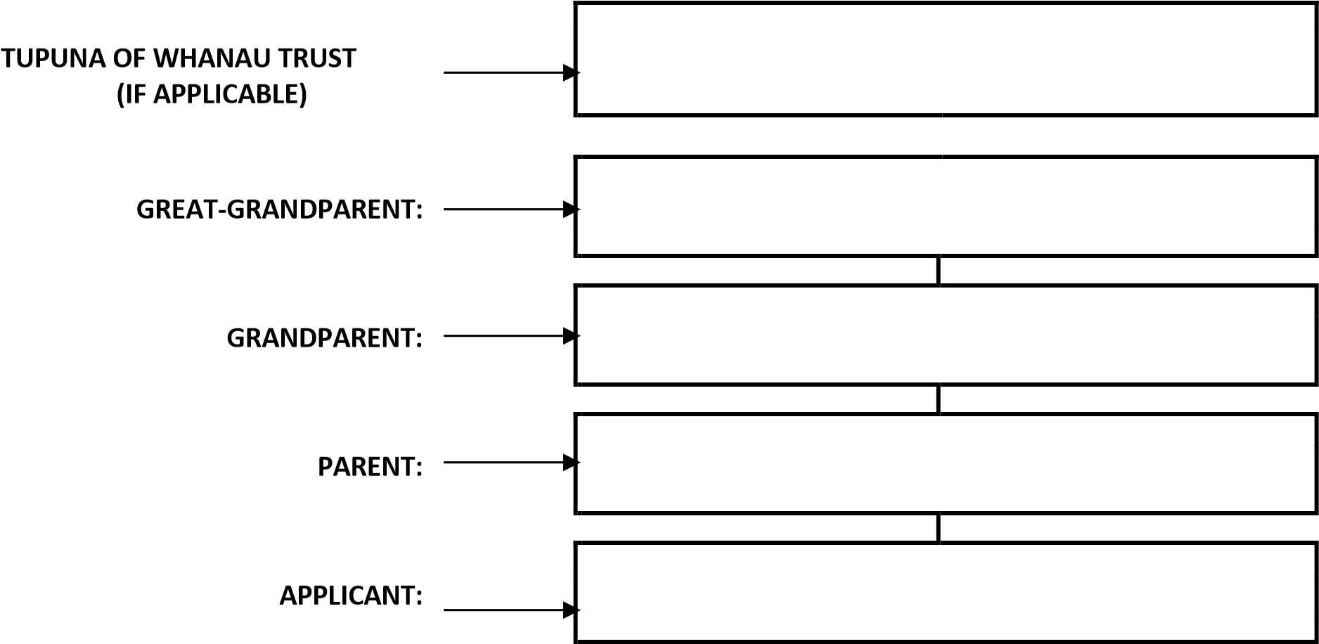

3.4 I ………………………………….………………………….(name) declare that the above Owner and whakapapa information is correct:

Signature of Owner or
Trustee of the Whanau Trust

APPLICANTS: READ THE NOTES ON THE NEXT PAGE

4. NOTES TO APPLICANTS

4.1 Only Owners, or their children, grandchildren, or great grandchildren (or beneficiaries under a Whanau Trust which is a Owner) are eligible for an education grant.

4.2. Students attending free courses are not eligible to apply.

4.3 Applicants must be enrolled at an NZQA approved (or overseas equivalent) tertiary education institution.

4.4 A bank deposit slip must be attached.

4.5 Confirmation of Enrolment. The application form must be accompanied by a letter or certificate from your educational institution that confirms and clearly outlines your enrolment. It must include:
- The Name of the Institution – preferably on their letterhead.
- Name of the student. iii. Programme of study being undertaken, clearly showing enrolled papers. iv. Year of study.
v. Signed and dated by the Registrar or Head of Department.

4.6 Academic Record. If you are in the 2nd year or higher of your programme of study, please include a copy of your results/academic record for each year of study. First year tertiary students please provide a copy of your most recent school results/records.

4.7 Receipt. This must confirm that your course fees for the year have been paid. Letter of Entitlement from Study Link is acceptable. Note, an invoice is not a receipt. If applicable, provide eligibility confirmation from Tertiary Education Commission re Fees Free study.

Pursuant to the PRIVACY ACT 2020 the following is brought to your attention:
- This application collects personal information about you.
- The information is collected to evaluate your application for an Education Grant. (c) The intended recipients of the information are the trustees of Parekarangi Trust.
- The information is being collected and held by Parekarangi A4 Trust, P O Box 987, Rotorua.
- You have the right of access to, and correction of, this information subject to the provisions of the Privacy Act 2020.

